Dear Families,
As you know, independent skills are critical to success in academics and our personal lives. Here is a host of fantastic games you can play with your child to build these skills while also spending time together.
The ability to focus and attend to lessons, directions, and conversations are fundamental skills that children learn as they watch adults, engage with peers, and are taught through natural experiences. Nothing is more natural for children than play, so why not build these skills through fun games that the whole family can enjoy?
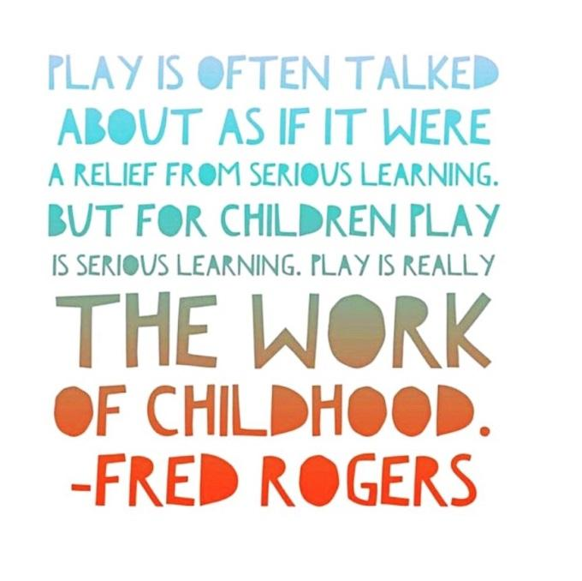
Attached you’ll find 10 fun games to play with your child(ren).

1. Red Light - Green Light
- An adult is the “traffic light” and stands at the opposite end of the room or field from the children.
- Hold up different colors to represent stop and go. Start with known cues of red and green but then – to challenge thinking –try different colors, such as purple for “go” and orange for “stop”. Try the opposite (red means go) or switch to using shapes or sounds to represent the actions.
- When someone “goes” when they should stop, simply have them go back to the starting line.
- Give children a turn being the traffic light.
2. Freeze!
- Everybody dances and when the music stops - freeze!
- Use a selection of both slow and fast songs and have children dance slowly to slow songs and quickly to fast songs.
- Challenge children by having them dance to opposite cues: dance quickly to the slow songs and slowly to the fast songs.
3. Conducting an Orchestra.
- Every child uses a musical instrument (real or improvised) and the “orchestra leader” uses a conducting baton. When the baton is up and waving, the children play their instruments. When the conductor puts the baton down, the children stop.
- Increase the complexity and attention required by having children play their instruments quickly when the baton moves quickly and slowly when the baton moves slowly. Try the opposite cues too.
4. Memory
- The classic game of memory-matching like cards from an array is a great way to build focus and attention. Share strategies for remembering the location of cards. Tip: Make sure your child does not change the card arrangement as matches are made and removed from the board.
5. Drum Beats
- Use drum beats to represent different actions that children can do while sitting (e.g. clapping or stomping) or while moving around the room (e.g. walking or dancing). For example, children walk quickly to fast drumming, slowly to slow drumming and freeze when the drumming stops.
- Request children to respond to opposite cues (walk slowly to fast drum beats and quickly to slow drum beats). Or add in different actions with specific drum cues. For example, slow drumming means stomping feet and fast drumming means jumping jacks.
6. Simon Says and Follow the Leader
- In either version of this game, the leader models different actions to be imitated. This builds impulse control, observation, imitation skills, and emotional regulation.
- With Simon Says, children must listen carefully because when Simon “does” an action but doesn’t say it, they shouldn’t follow!
- Up the ante by introducing actions that have multiple steps.
- Try having two groups going on at the same time, with two Simon’s or “leaders.” When a child gets mixed up with their actions, they simply join the other group and follow a new leader (instead of being “out”).
7. Melting snowman
- The Melting Snowman game focuses on children’s self-awareness.
- Start by asking the children to stand tall like a snowman.
- Children then either relax or tense their bodies based on cues the adult provides. When the sun is coming out, children relax or begin to melt. When the snow clouds roll back in and it gets cold, children tense or freeze.
8. Go & Grab
- This game supports memory and attention to detail. Instruct your child to go and get an item in the room and bring it to you.
- Build in the challenge by adding additional items, silly movements, more specific items (tall green glass) sending your child a greater distance, and adding tasks to do with the item once they bring it. Try giving all directions at once for a child to remember
- Example:
Level 1: go & grab the remote
Level 2: go & grab the remote and green dog toy
Level 3: go to the kitchen & grab a tall, red, cup and place it upside down next to me.
Level 4: go to the kitchen & grab a tall, red, cup and place it upside down next to me and roar like a lion!
- Give your child the opportunity to give the directions too. They’ll need to remember their directions to verify the adult or sibling followed through will all directions!

9. Head-Shoulders-Knees-& Toes
- This classic activity requires children to work on their self-regulation skills by overriding automatic responses as the song is changed.
- Begin by having students point to their head, shoulders, knees, and toes while singing the song.
- Challenge them by omitting body parts in the sequence and/or by asking students to point to incongruent body parts. For example, tell students “when I say to touch your head, touch your TOES!!" or "When I say touch your tummy, touch your EARS."
10. Puzzles (affordable options via eBay and the dollar store)
- Spend time together working on a puzzle. This can be a simple or more complex puzzle. The key is to start with a small amount of time and add on to build confidence and stamina. If you have a large puzzle decide on an amount of time to focus on the puzzle before taking a break. Depending on the student the time may vary.
- If it’s a short and simple puzzle add a level of challenge by setting a timer and seeing how long it takes your student to complete the puzzle. Challenge them to beat their previous time.

11. Questions
- “Questions” is a fun game that helps children focus on one item as they learn about it. This activity requires them to concentrate on one specific subject or item at a time, a valuable skill at school. This activity can also be modified with tougher questions.
- Place an item in front of the child. They are then allowed to look at it briefly.
- Take the item away from view and asks them a series of questions one right after the other quickly. Start with larger and more obvious questions about the item and become more specific.
12. The Coin Game
- This is a fast-paced game that improves memory and sequencing skills as well as concentration.
- Take a pile of assorted coins, then choose five and arrange them into a sequence: for example 2 pennies, 1 dime, 1 nickel, 1 quarter. Get your child to look at them closely for 15 seconds or so, then cover them with a sheet of paper.
- Ask your child to make the same pattern using the coins in front of them, timing them with a stopwatch. When they’ve finished, note down the time they took and whether or not they got the pattern right; if they didn’t, get them to try again until they’re correct.
- The more you play this game, the faster and more accurate your child should get – and you can increase the difficulty by using more coin denominations or longer sequences.
13. Did You Notice?
- This game is a great way to help children develop their concentration skills.
- Take a selection of small household objects, such as a teaspoon, a key, a hair clip, an egg cup – you’ll need about 20 in total – and arrange them on a tray. Give your child 30 seconds to study the objects, then cover them up with a towel.
- There are then two ways to play the game: either you can ask your child to recall as many objects as possible within a set time, or you can sneakily remove one item then uncover the tray and ask them to identify what’s missing.
14. “I went to the store and I bought…..”
- This traditional game is a good group exercise that you can play with your child and their siblings or friends, and that often ends with much hilarity.
- Sitting in a circle or around a table, the first person says, ‘I went to the supermarket and I bought…’ and then names an item starting with A: for example, an avocado. The next person then repeats the sentence and names an object starting with B, but also has to recall the first person’s answer: so, ‘I went to the supermarket and I bought an avocado and a balloon.’
- Carry on through the alphabet, seeing how many objects you can remember before it all falls apart!

Games I played this week!

 | Monday | Tuesday | Wednesday | Thursday | Friday
Red Light, Green Light!
Freeze!

Conducting an Orchestra!
Memory!
Drum Beats
Simon Says/ Follow the Leader
Melting Snowman
Go &Grab!
 | Monday | Tuesday | Wednesday | Thursday | Friday
Head, Shoulder, Knees, and Toes
Puzzles

Questions

The Coin Game

Did You Notice?

I went to the store and bought…..

